**DESIGN AN 8-TO-1 MULTIPLEXER USING TRANSMISSION GATE LOGIC**



## Birla Institute of Technology and Science, PILANI

## FINAL REPORT

Submitted in partial fulfilment of course

**EEE F313 – Analog & Digital VLSI Design**

## First SEMESTER 2017-18

BY

**Mohit Garg**  *2015A3PS0231P*

**Digvijay Bansal** *2015A3PS0187P*

**Mohit Padhye** *2015A3PS0137P*

**Mayank Raj**  *2015A8PS0488P*

SUBMITTED TO

**Dr. Anu Gupta**

*Professor, Department of Electrical and Electronics Engineering*

**Dr. Nitin Chaturvedi**

*Assistant Professor, Department of Electrical and Electronics Engineering*

**Problem 14 - A**

**Multiplexer using transmission gate logic style**

Design an 8-to-1 multiplexer using transmission gate logic at 200MHz frequency with 500fF load capacitance.

**Specifications and Assumptions**:

* TSMC018 technology
* L = 180 nm for all transistors
* λ = 0.09 μm
* Layout for capacitance and resistor are not drawn
* Body of PMOS is connected to VDD and body of NMOS is connected to GND
* A single VDD and GND are used throughout the circuit
* Operating frequency of 200MHz is specified.
* Load Capacitance is given 500fF.
* The assumed ambient temperature for which the results are presented is 27℃
* The ratio of mobility of majority charge carriers in NMOS to PMOS is µn=2µp

**Layout (with DRC Check)**

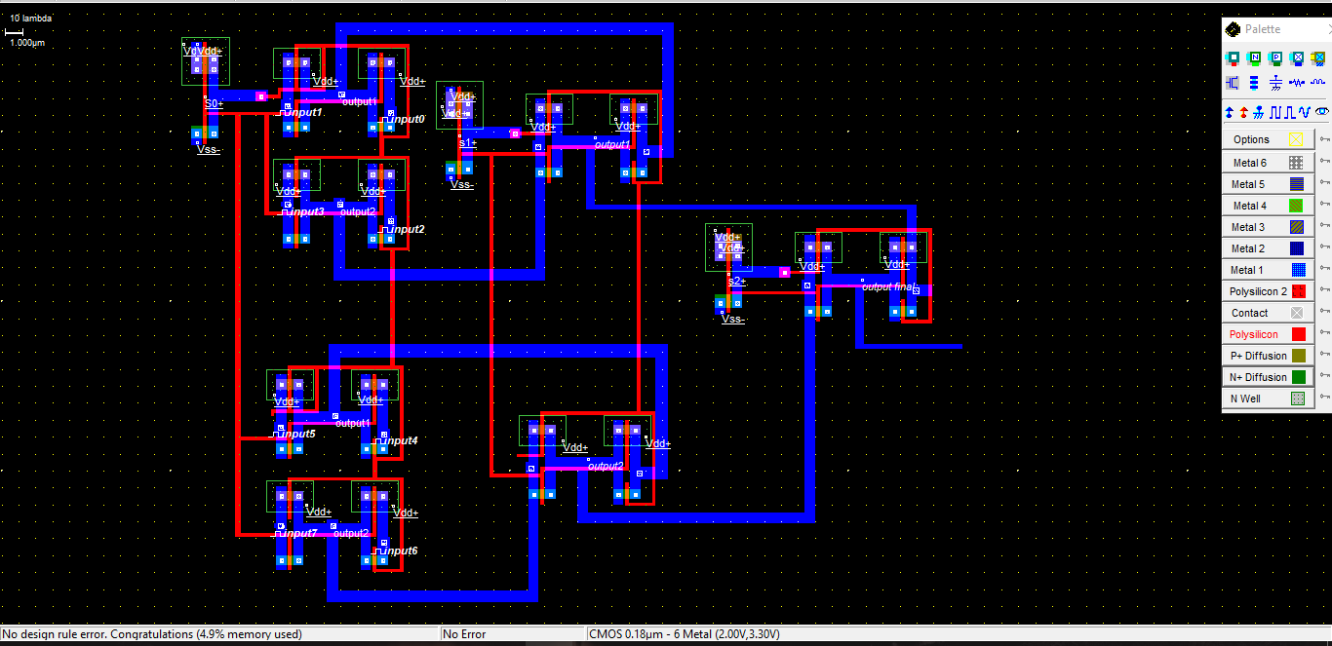

Fig. Layout for 8:1 Multiplexer using Transmission Gate Logic

**Schematic**

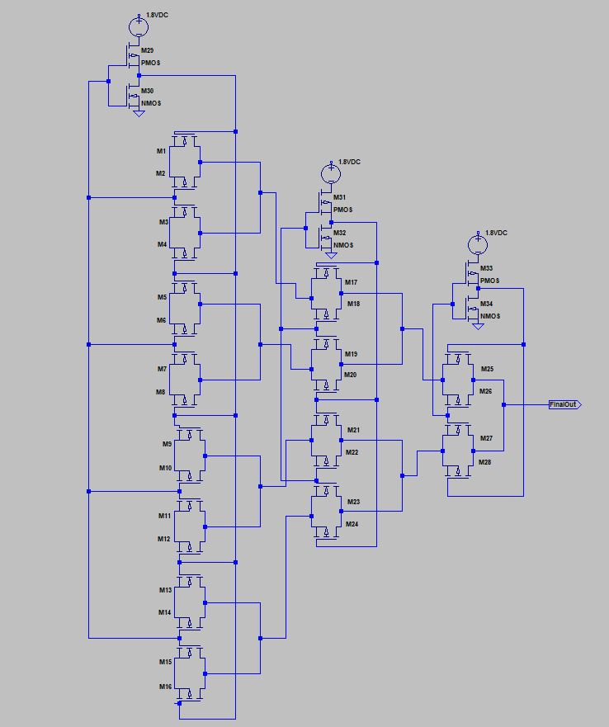

Fig. Schematic of the 8:1 multiplexer using Transmission Gate Logic

**No. of Transistors**:   
**Transmission Gates** – 14 (14 NMOS – W/L = 3; 14 PMOS – W/L = 3)   
**Inverters** - 3(3 NMOS – W/L = 4; 3 PMOS – W/L = 8)

**W/L Calculations**

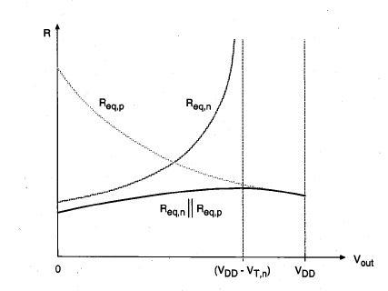

Fig. Equivalent resistance of the CMOS transmission gate, plotted as a function of the

Output voltage.

As seen from above graph, is maximum when NMOS is OFF and PMOS is in Linear Region.

As W/L Increases, RT Decreases → Delay (0.69RonCL).  
But C ≈ Cjsw. (P) + CjA. (A)

P ∝ W and A ∝ W.  
So, C ∝ W.  
As W/L Increases, RT Decreases → But Capacitance Increases.

Thus an optimum point is found using HSPICE.   
As shown in figure, on increasing W/L from 2 to 4, delay decreases but it is quite small when W/L goes from 3 to 4.   
Thus, to prevent MUX from occupying disproportionately large area, we choose W/L = 3 for transmission gates.

In the graph below, the red curve denotes the input waveform with a rise time and fall time of 0.1ns each. The yellow curves denote the output waveform, each representing a different value of channel width from 0.6µm to 1.8µm. As W/L increases, the delay decreases by a very negligible amount. However, as a trade-off, the size of the transistor increases in a much larger proportion, with a very marginal decrease in delay. Hence, minimum size of W=0.6µm has been chosen for the transmission gates MOSFETs.

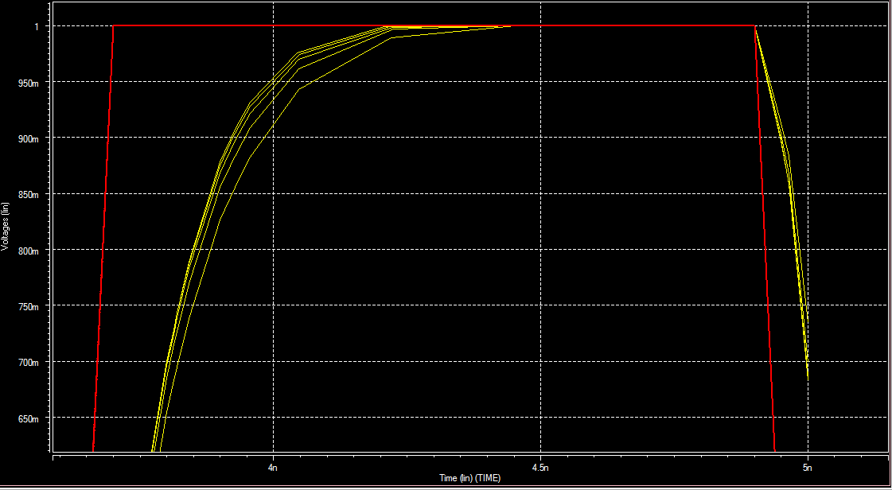

Fig. Graph showing transient analysis to choose proper sizing of transistors

Similarly, the graph plotting the transient analysis to choose W/L for the inverters is shown ahead. The red curve represents the input whereas the yellow curves represent the output curve, each for a different value of channel width. We can see from the graph that as W increases, the delay reduces significantly. After increasing to an appreciable value, however, the increase becomes very marginal. We can afford to increase the widths of a few transistors by a small amount if we are getting appreciably reduced delay. Hence, the W/L of the NMOS has been chosen to be 0.8µm and that of PMOS is 1.6µm. A pull-up to pull-down ratio of 2:1 has been maintained for stable voltage transfer characteristics of the CMOS inverters.

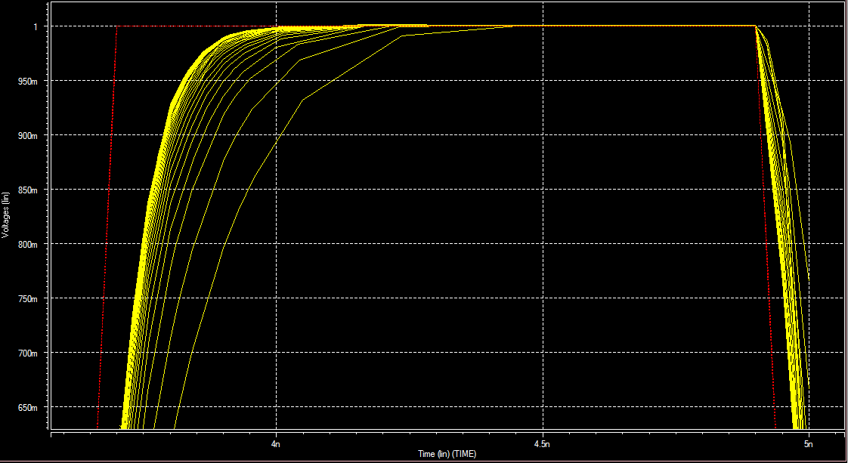

Fig. Graph showing transient analysis to choose proper sizing of transistors

**Output Waveforms**  
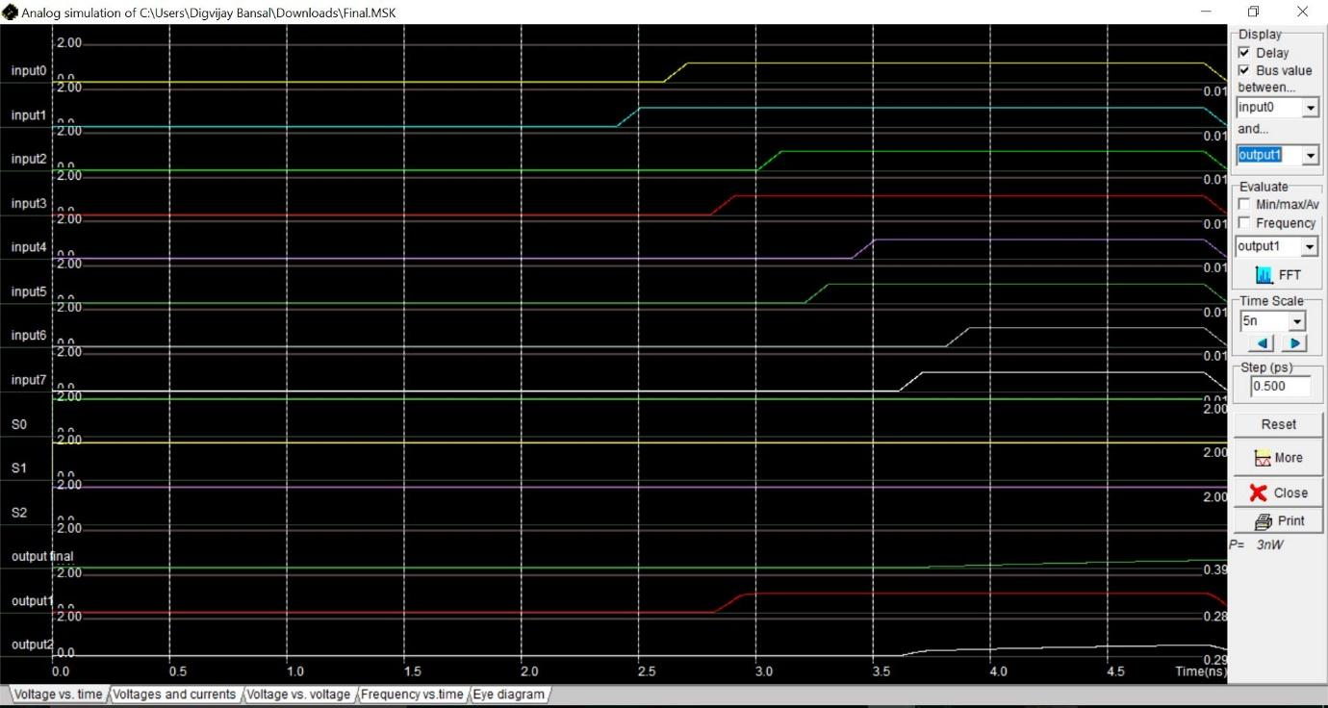

Fig - Output Waveforms of 8:1 MUX (Output Final = Input 7)

With Load Capacitance (500fF).   
The select lines are given – 111 as Input.

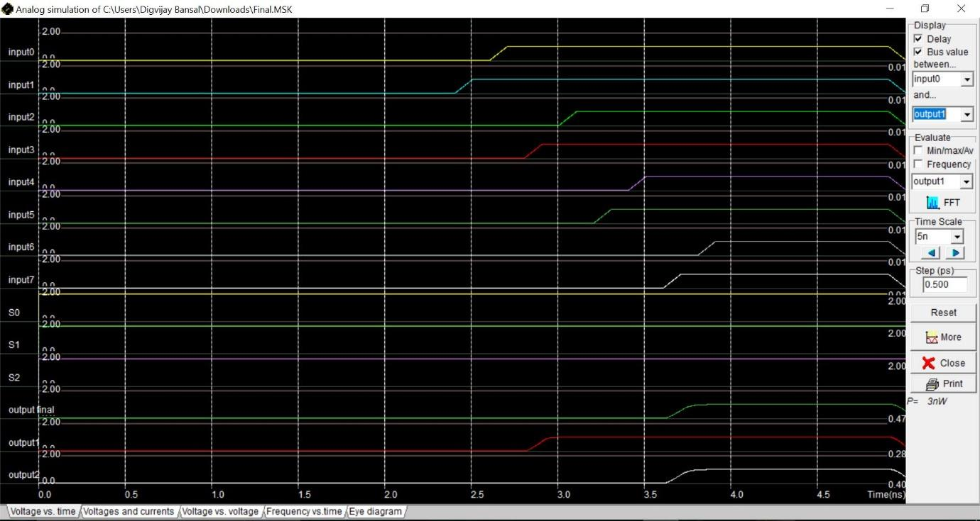  
Fig - Output Waveforms of 8:1 MUX (Output Final = Input 7)

Without Load Capacitance (500fF).   
The select lines are given – 111 as Input.

**Delay Calculations**According to the schematic of the 8:1 MUX, every input has to go via the same path of 3 transmission gates to reach the final output as per the inputs given in the select lines.

So, delay calculation will include 3 transmission gates and their intermediate capacitances, the calculation is done via Wire Delay Model. 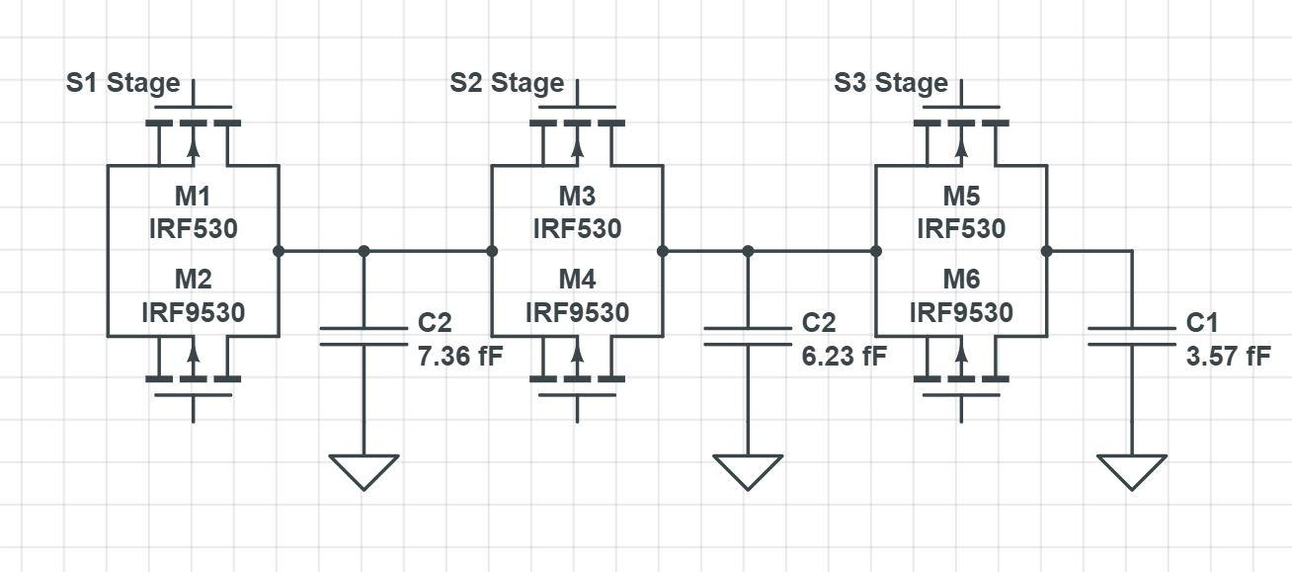

Without Load Capacitance (500fF).   
The select lines are given – 111 as Input.

Wire Delay =

R1, 2, 3 = 9.6618 KΩ

Capacitance values have been extracted from

C1 = 7.36fF

C2 = 6.23fF

C3 = 3.57fF

**τ** = 0.2035ns

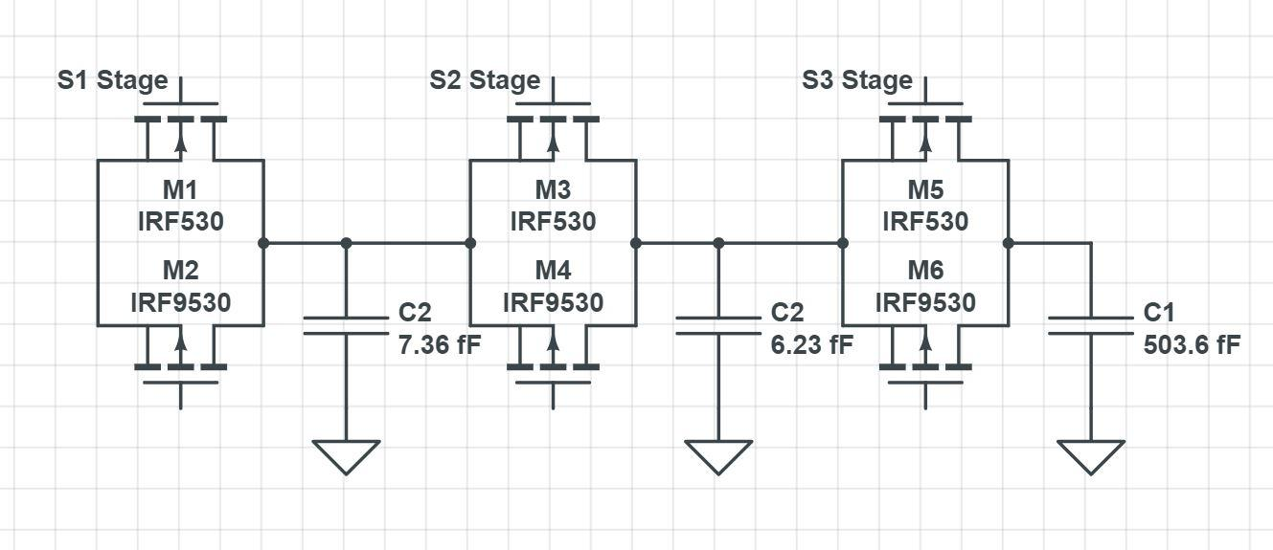

With Load Capacitance (500fF).   
The select lines are given – 111 as Input.

Wire Delay =

R1, 2, 3 = 9.6618 KΩ

C1 = 7.36fF

C2 = 6.23fF

C3 = 503.57fF

**τ** = 10.20ns

The SPICE model files used in the layout are as follows:

* n-mos model 3 :

* low leakage

.model n1 nmos level=3 vto=0.50 uo=115.000 tox= 4.0e-9

+ld =-0.020u theta=0.200 gamma=0.350

+phi=0.500 kappa=0.080 vmax=100.00k

+cgso=100.0p cgdo=100.0p

+cgbo= 60.0p cjsw=240.0p

*

* p-mos model 3:

* low leakage

.model p1 pmos level=3 vto=-0.60 uo=30.000 tox= 3.0e-9

+ld =0.010u theta=0.300 gamma=0.400

+phi=0.200 kappa=0.010 vmax=100.00k

+cgso=100.0p cgdo=100.0p

+cgbo= 60.0p cjsw=240.0p

*

The threshold voltage for the NMOS is 0.5V and that for the PMOS is -0.6V.

**Practical Values of Delay**

Graphs have been plotted in SPICE to measure the value of propagation delay. Delay has been calculated till half the maximum value of the voltage. Following figure shows the transient analysis for the output and the input. The red curve is the input whereas the yellow curve is the output.

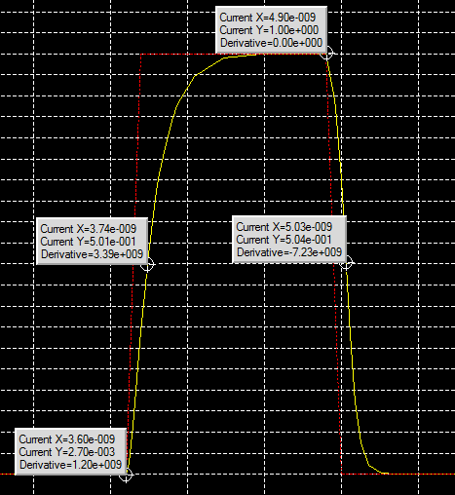

Fig. Time response of input and output for delay calculation

The low to high time propagation delay is:

𝝉pLH = 3.74ns - 3.60ns = 0.14ns

The high to low time propagation delay is:

𝝉pHL = 5.03ns - 4.9ns = 0.13ns

Hence, the average time propagation delay is:

𝝉p = (𝝉pLH + 𝝉pHL)/2 = (0.14ns + 0.13ns)/2 = 0.135ns

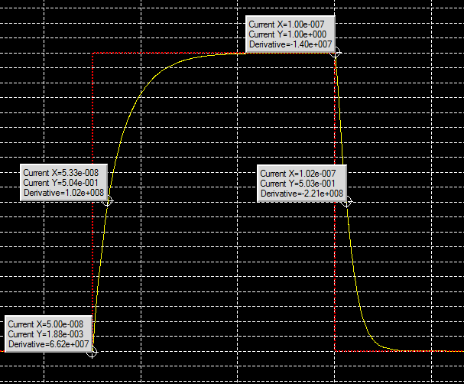

Fig. Time response of input and output for delay measurement

The low to high time propagation delay is:

𝝉pLH = 53.3ns - 50ns = 3.3ns

The high to low time propagation delay is:

𝝉pHL = 102ns - 100ns = 2.0ns

Hence, the average time propagation delay is:

𝝉p = (𝝉pLH + 𝝉pHL)/2 = (3.3ns + 2ns)/2 = 2.65ns

**RESULTS:**

|  |  |  |
| --- | --- | --- |
| **Parameter** | **Calculated Value**  **(Worst Case)** | **Measured Value** |
| Time propagation delay | 0.2035ns | 0.135ns |
| Time propagation delay (with 500fF load) | 10.20ns | 2.65ns |

**Power Consumption**

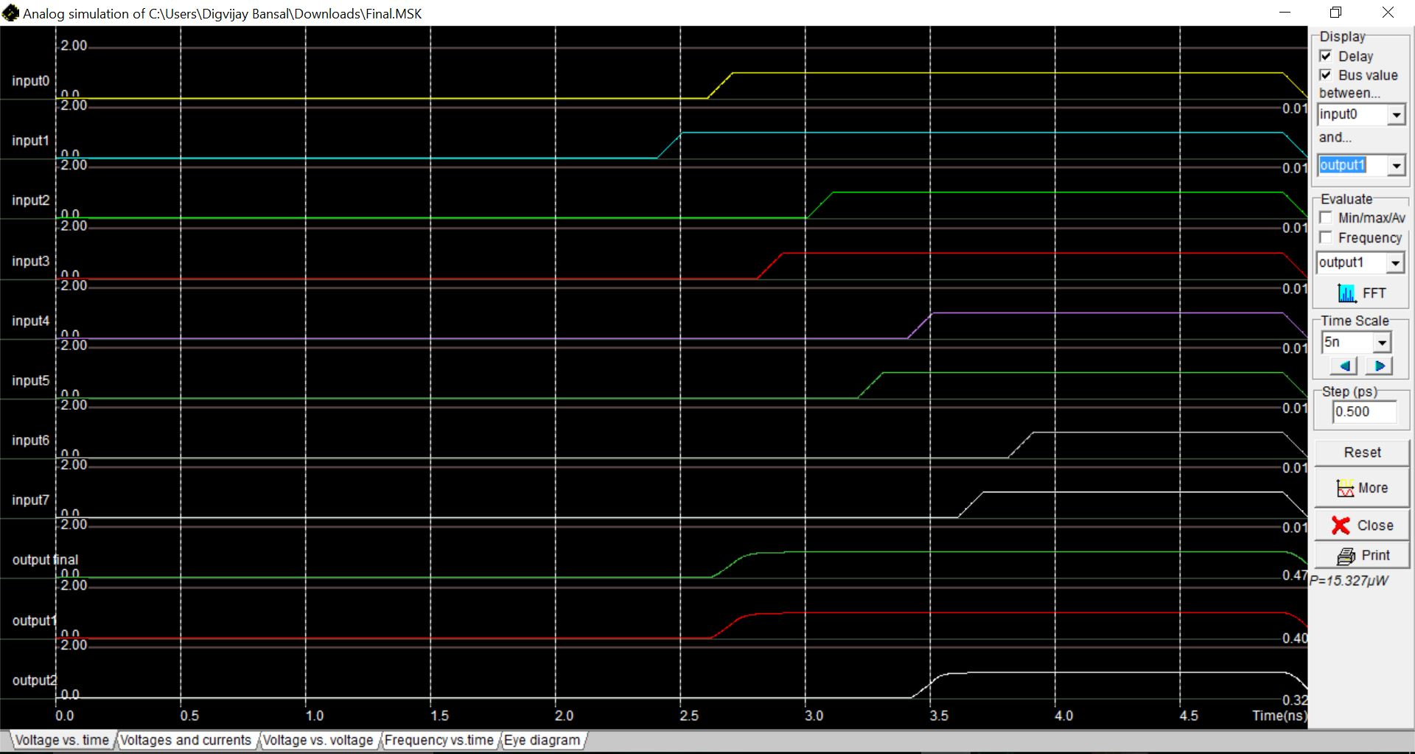

Select Lines - 000

Power Consumption – 15.327µW  
  
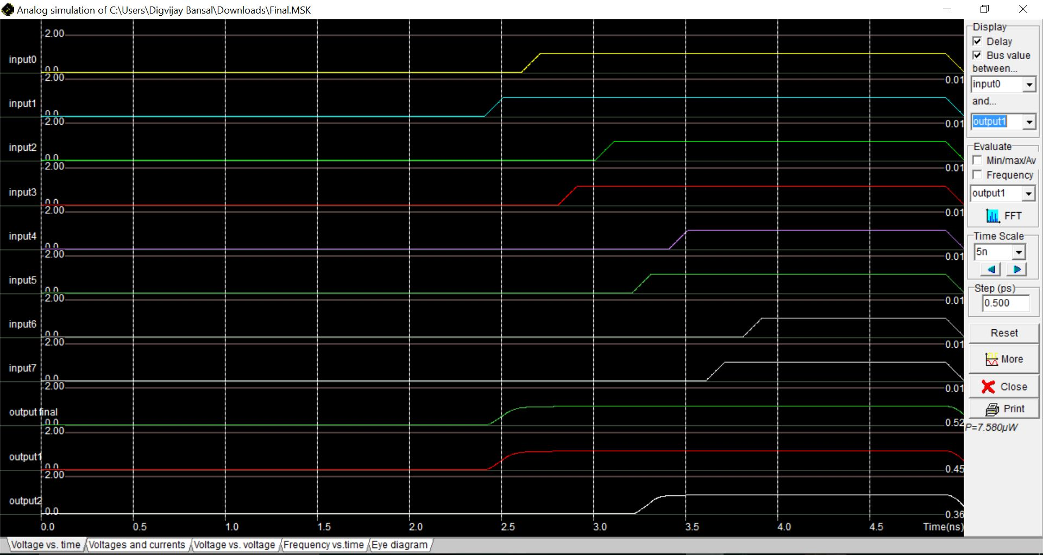

Select Lines - 001

Power Consumption – 7.580µW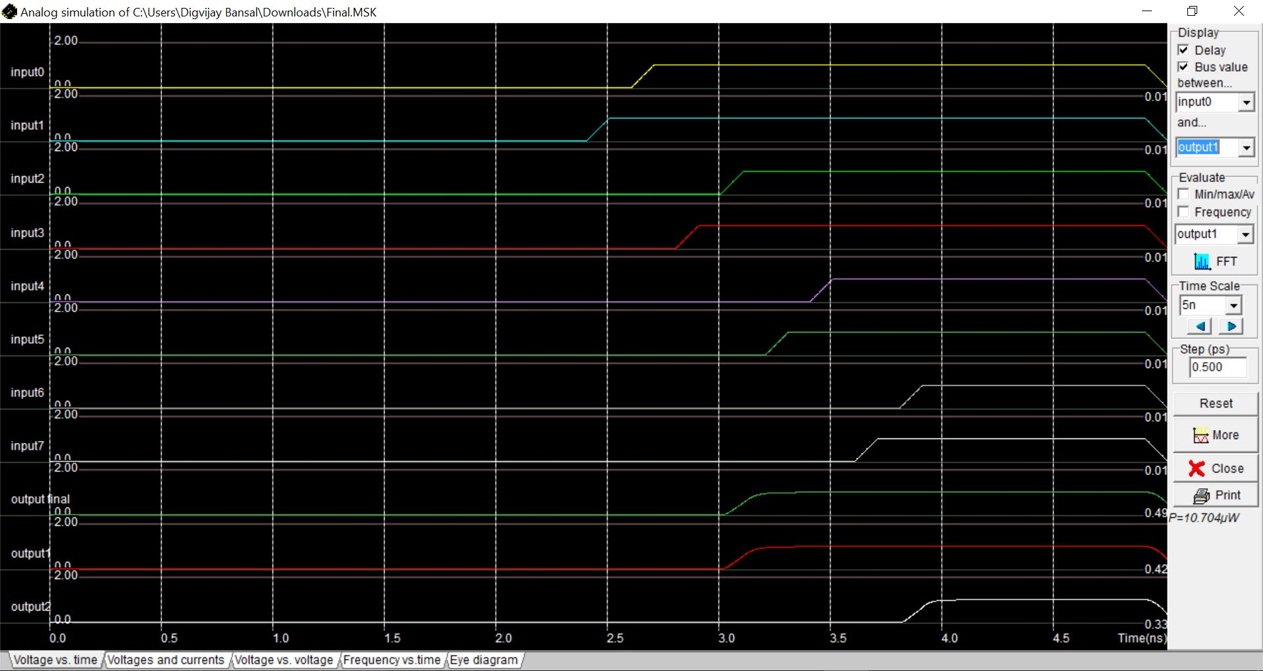

Select Lines – 010

Power Consumption – 10.704µW

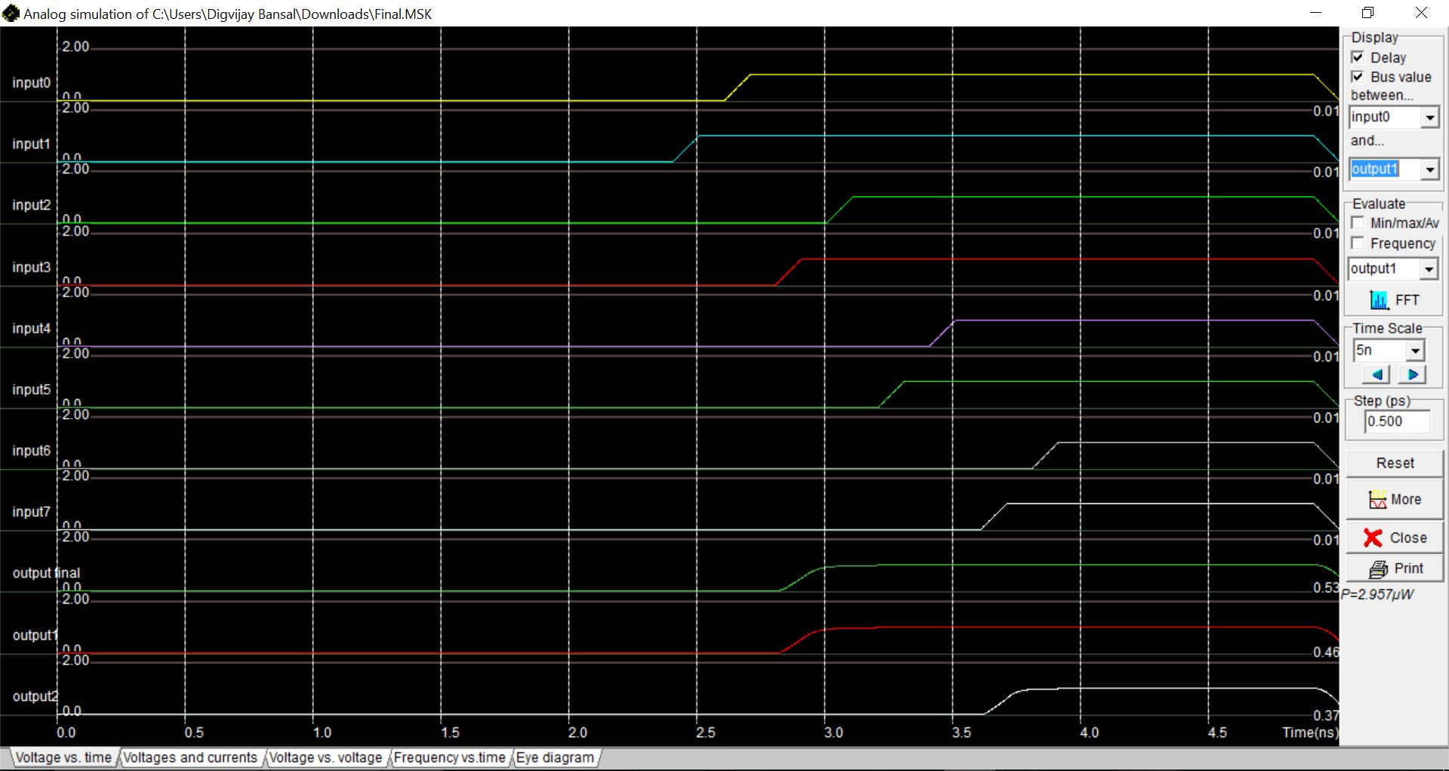

Select Lines - 011

Power Consumption – 2.957µW

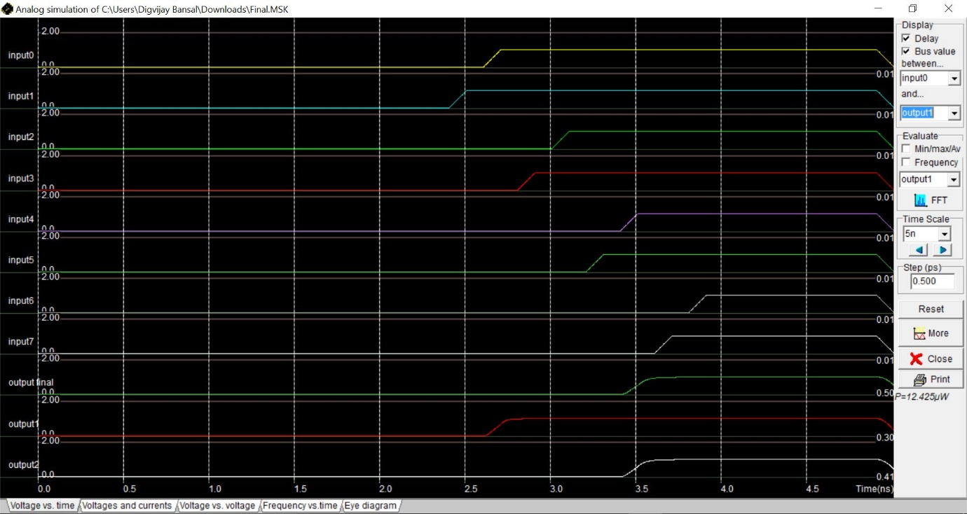

Select Lines - 100

Power Consumption – 12.425µW

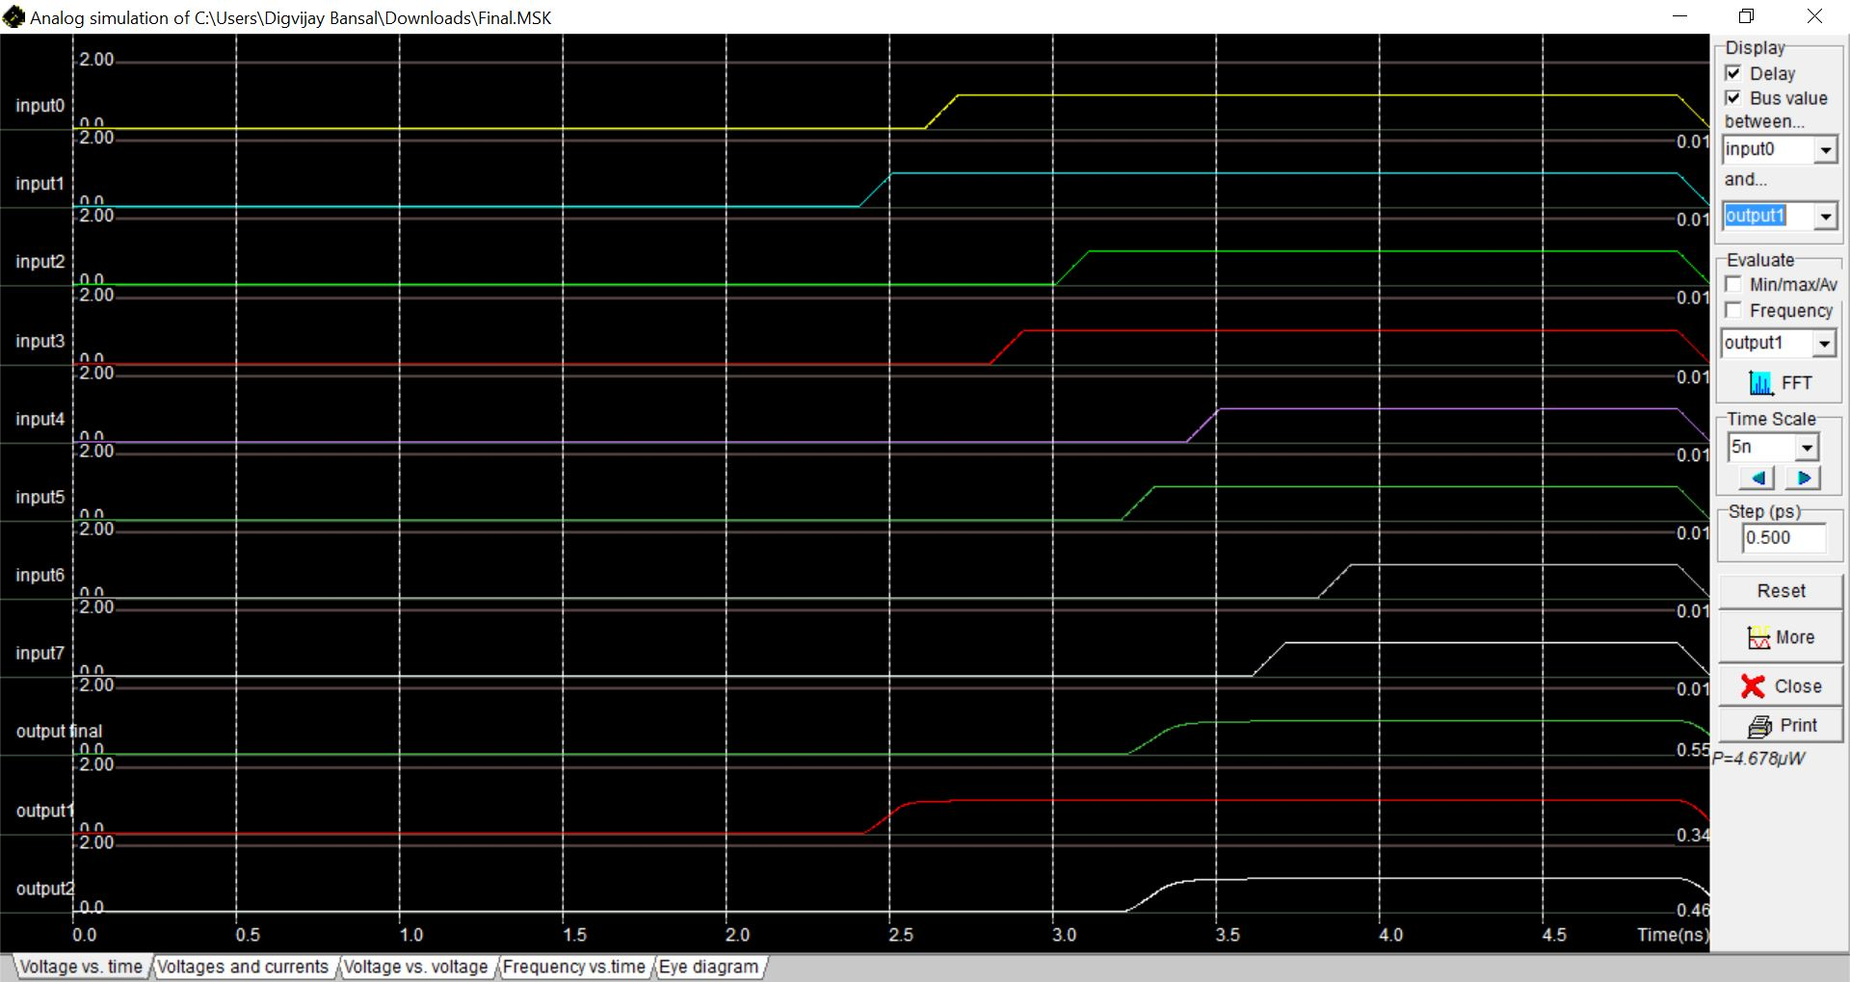

Select Lines - 101

Power Consumption – 4.678µW

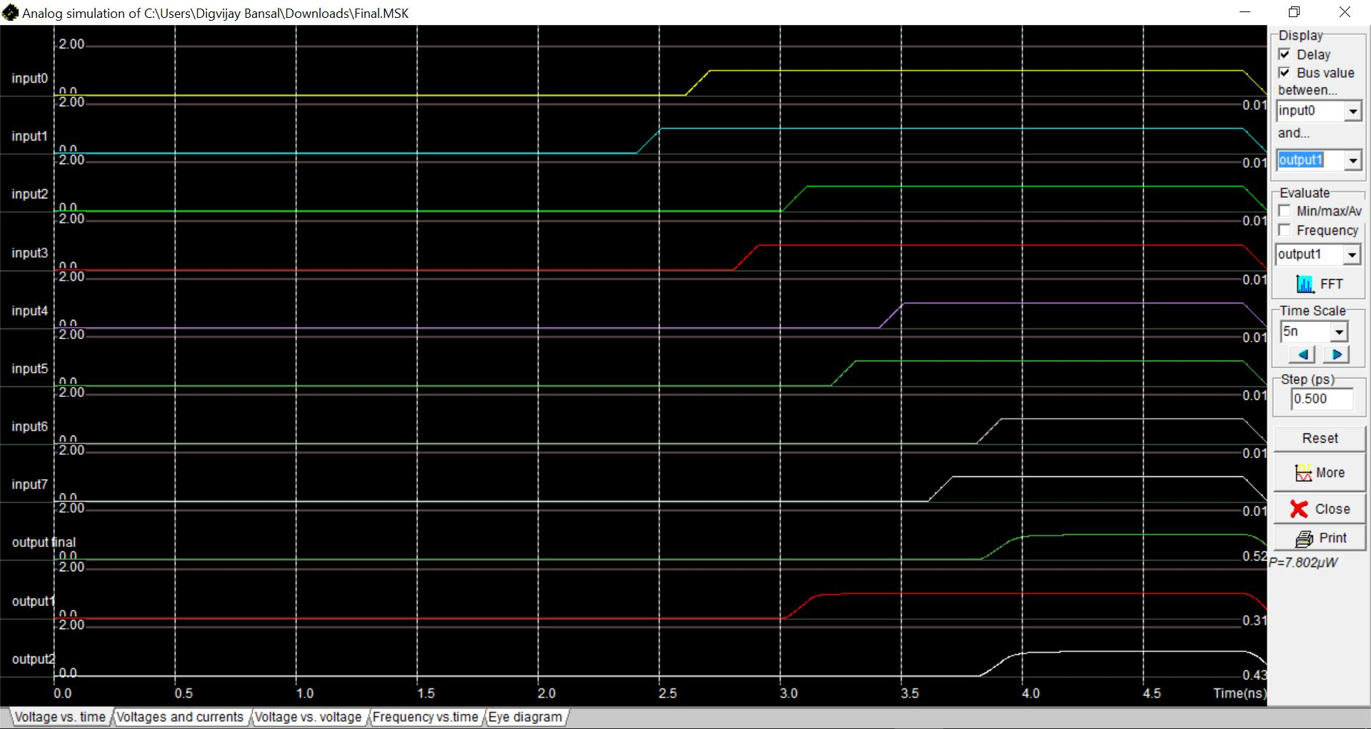

Select Lines - 110

Power Consumption – 7.802µW

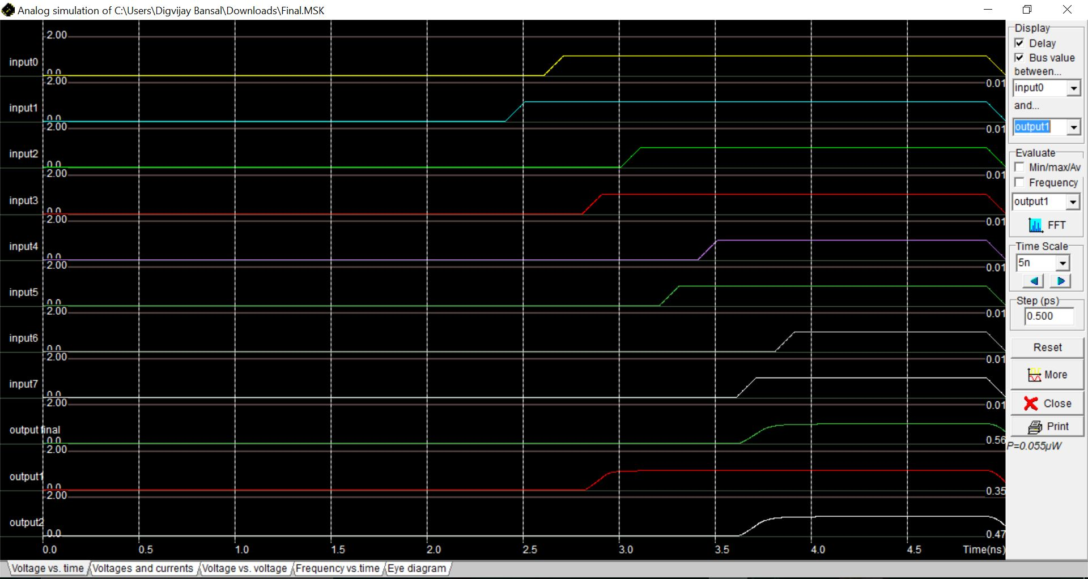

Select Lines - 111

Power Consumption – 0.055µW

**Problem 14 – B**

**Verilog Program**

Implement Non-restoring division algorithm for dividing six bit number by a three bit number. Use the modelling style of your choice.

Algorithm as per Digital Design Course:

**Non- Restoration Algorithm**

Non-restoration method eliminates the need for restoring.

Initializing the Registers.

* Divisor is loaded into M.
* Dividend loaded into Q.
* Initialize A to Zero.

Algorithm

* If sign of A is positive shift A & Q left by one bit and subtract M from A.

OR

* If sign of A is negative, shift A &Q by one bit and add M to A.
* If MSB of result is 1, then Q0 is set to zero otherwise set to one.
* Repeat steps 1-2 n (number of bits in dividend) times.
* At the end if sign of A is negative add M to A to get the correct remainder.

**Verilog Code  
  
module** final_algo**(**dividend**,**divisor**,**rem**,**quo**);** //Initializing the module, Three Inputs

**input** **[**5**:**0**]** dividend**;** //6-Bit Register

**input** **[**2**:**0**]** divisor**;**// 3-Bit Register

**output** **[**5**:**0**]** rem**;**// 6-Bit Register, Remainder

**output** **[**5**:**0**]** quo**;**// 6-Bit Register, Quotient

**integer** i**;** // Declaring Integer for Loop

**reg** **[**5**:**0**]** Q**;** // Intermediate Registers for Value Holding (Dividend)

**reg** **[**5**:**0**]** M**;** // Intermediate Registers for Value Holding (Divisor)

**reg** **[**5**:**0**]** A**;** // Intermediate Registers for Value Holding

**always@(**dividend **or** divisor**)**

// Always Checks For Non-Negativity Condition

**begin**

M **=** 0**;** M **=** M **+** divisor**;** // As Divisor is 3 Bit and M is 6 Bit

Q **=** dividend**;**

A **=** 0**;**// Initializing with Zero, As Per Algorithm

**for(**i**=**0**;** i**<**6**;** i**=**i**+**1**)**//Looping No. of Bits(6) in Dividend Times

**begin**

**if(**A**[**5**]==**0**)** //Checking The Sign of the Dividend(Positive)

**begin**

A **=** A **<<** 1**;** //Left Shift the Bits of a Register

A**[**0**]** **=** Q**[**5**];** //As Verilog Shifts Circularly, Manual Shifting

Q **=** Q **<<** 1**;** // Left Shift the Bits of Q Register

Q **=** Q **&** 6'b111110**;** //As Verilog Shifts Circularly, Manually Inserting Zero at End

A **=** A **-** M**;** // Subtracting A from M

**end**

**else** //The Loop When A is Negative

**begin**

A **=** A **<<** 1**;** //Left Shift the Bits of a Register

A**[**0**]** **=** Q**[**5**];**//As Verilog Shifts Circularly, Manual Shifting

Q **=** Q **<<** 1**;** // Left Shift the Bits of Q Register

Q **=** Q **&** 6'b111110**;** //As Verilog Shifts Circularly, Manually Inserting Zero at End

A **=** A **+** M**;** // Adding A and M

**end**

**if(**A**[**5**]==**1**)**// Checking MSB

**begin**

Q **=** Q **&** 6'b111110**;** //Setting LSB of Q = 0

**end**

**else**

**begin**

Q **=** Q **|** 6'b000001**;** //Setting LSB of Q = 1

**end**

**end**

**if(**A**[**5**]==**1**)** // Checking MSB

**begin**

A **=** A **+** M**;** // Adjusting the Remainder

**end**

**end**

**assign** quo **=** Q**;** // Assigning Values to Quotient

**assign** rem **=** A**;** // Assigning Values to Remainder

**endmodule**

**Verilog Example**

**Dividend: 6’b0000111**

**Divisor: 3’b010**

**Quotient: 6’b000011**

**Remainder: 6’b000001**

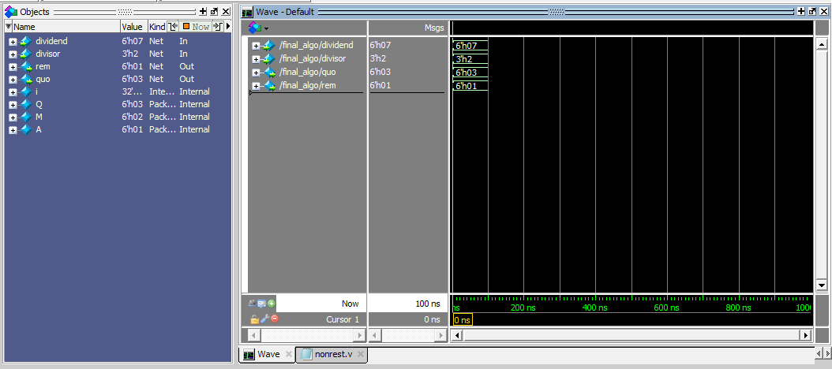

Fig -Final output of Non Restoration Division Algorithm.